Implementation Summary

Explanation & Justification
I picked the bank marketing dataset because it comprises of data related to real marketing campaigns conducted by a Portuguese banking institution, so I felt comfortable knowing that the datapoints included would allow me to create a realistic example of how the selected AI technique could be helpful to real banks. This is important for tuning the model parameters.
The goal of the selected dataset is to predict if a client will subscribe to a term deposit. This can be valuable to banks since marketing is a big expense and focusing marketing on customers that are more likely to subscribe lowers cost per acquisition (and by extension, results in a higher return on investment for the bank).
How Random forrest Works
- Bootstrap aggregating (Bagging): each tree is trained on a different random sample of the training data (sampled with replacement). This introduces diversity between trees and reduces the overall variance of the ensemble compared to a single tree.
- Random feature selection: at every node split, only a random subset of features (square root of the total by default) is considered as candidates. This decorrelates the trees so that no single dominant feature controls all predictions.
- Majority voting: the final prediction is the class voted for by the most trees. Averaging across many diverse trees smooths out individual errors and produces a more stable result.
- Feature importance: each tree records how much each feature reduces node impurity at its splits. Averaging these scores gives a mean decrease in impurity (MDI) ranking across the full forest, a native measure of which features matter most.

Why Random forrest Was Selected
Random forrest was selected because it handles mixed data types naturally: no distributional assumptions are required. Numeric and encoded categorical features work directly as input without any special treatment.
Another reason is built-in class imbalance handling: the class_weight="balanced" parameter automatically increases the training cost of missing a minority-class (subscriber) example, directly addressing the 89/11 split without resampling the data.
Banks also need to understand which client attributes drive predictions. MDI scores provide this natively and in a way that non-technical stakeholders can understand. Bagging and random feature selection act as strong implicit regularisation, important here given the relatively small dataset of 4,119 records.
By using Random forrest as the ai technique , I can correctly filter out the majority of customers that will not subscribe (80%), leaving behind a much smaller list of customers where 50% would subscribe.
Being able to filter out as many customers that won’t subscribe as the model did could save as much (80%) in marketing spending (leaving out computational costs), since the bank would be able to skip reaching out to that many customers.
There are some false positives as expected, but they are small compared the the true positives. For a first pass/initial marketing campaign, this would be very valuable compared to more expensive models when considering the accuracy we can achieve with Random Forrest.

Data Preparation
The data is prepared first at the top of the python script before training the model in the following steps:
- Replacing “unknown” values in the original dataset with their columns mode.
In this case I am looking for missing values, represented as “unknown” in this dataset. I could have dropped the rows that have missing data, but I opted to replace these values with the columns mode value (the most common value). Removing rows is less beneficial for us, especially since the dataset in our case is not massive (if I had a bigger dataset I could potentially remove rows with missing data to see an increase in accuracy, at the cost of leaving out customers).
- Encode education column into ordered numbers.
The model should recognise that certain levels of education are better or held in higher regard. To achieve this, I manually order each field and assign them to a number from 0-6. This is required manually because skikit-learn’s LabelEncoder (fit_transform) would do its own ordering on the data, which could wrongly assign lower levels of education as higher integers.
- Encode default, housing, loan, y columns into binary (0/1).
Now I loop over columns that I can represent as a simple binary value, turning “no” into 0 and “yes” into 1.
- Encode contact column into binary.
The contact column doesn’t store a no/yes string, so I handle this one separately, turning “cellular” into 1 and “telephone” into 0.
- Encode categorical columns with LabelEncoder
For the remaining columns that are categorical, I use the LabelEncoder from scikit-learn to normalise values in numbers.
This step in the script ends by writing the new processed data into the bank-additional_preprocessed.csv file so that it can be inspected. Looking at the data manually helps verify that the preprocessing step is doing what it should.

Implementation

Training
I performed a regular 80/20 split for training and test data.
The following hyperparameters were defined:
- n_estimators: The number of trees in the forrest. With a choice of 100, 300, 400 and 500, the best landed on 300.
- max_leaf_nodes: Max leaves per tree. With a choice of 8, 16, 32, 64 and 128, the best landed on 64.
- class_weight: Class weights. With a choice of None or balanced, balanced was best. Balanced will cause missing a subscriber to be more costly for the model in training.
- min_samples_leaf: The minimum number of samples required to be in each leaf. From a choice of 1, 3 or 5, 1 was best.
I found that the most important parameters/adjustments that I have made were using the balanced class_weight in conjunction with the f1 (balanced F-measure) metric as the score used in GridSearchCV.
Figure 1-Best hyperparameters
The balanced weight makes the model more likely to pick a customer as one that it thinks will subscribe because it will make missing a customer that would have subscribed more costly, the result is we get the model to pick more (even if it increases false positives slightly) instead of leaving loads of potential customers off the table by being too safe.
The f1 metric used as the scoring strategy for evaluating the performance of the model strikes a balance between precision and the ability for the model to find all positive instances. This helps greatly getting the end model to pick more potential customers and is a terrific trade-off that predicts much more subscribers correctly, with the increase in false positives only following slightly.

Results
Our script outputs our models accuracy results as a very simple bar chart and a new csv file that the real bank would be able to use as a contact sheet for direct marketing from the test data.
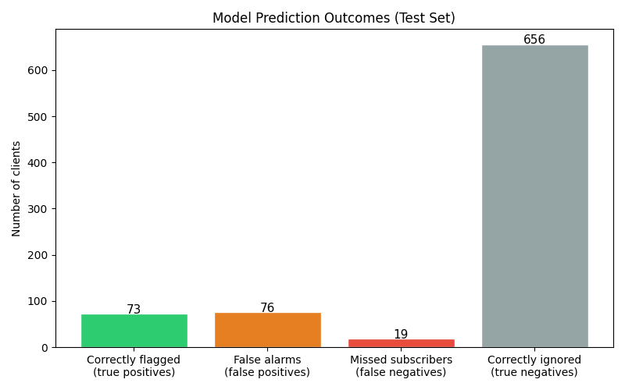
Figure 2-Prediction outcomes
The model predicts a total of 149 customers are recommended to be conacted, however only 73 would actually subscribe (~49%). A marketing campaign that can get (about) every other customer they call to subscribe would be hugely profitable for the bank. If this were compared to cold calls to every customer, you could only expect ~11% of calls to result in a subscriber.
We can see from the chart that 19 customers that would subscribe were missed from the models prediction on the test data. In the real world, this is lost revenue, but the missed subscribers compared to the amount of subscribers the bank can get in a much smaller number of total calls is a tremendous trade-off in cost and gain.
A bank using this model can focus more resources on the models predicted customers, ensuring they get all possible subscribers. The rest of the customers can be targeted with cheaper marketing methods, which could result in a good portion of the (19, in this case) missed subscribers subscribing. This will save banks immense amounts of money.
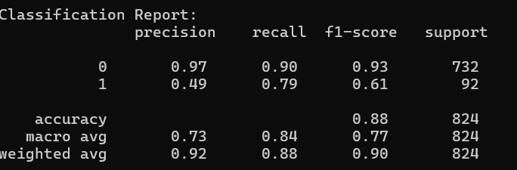
Figure 3-Classification report

As can been seen in figure 3, script also outputs a full classification report which breaks down model performance per class, a much more honest picture than accuracy alone, especially with an imbalanced dataset like this one. The report gives four numbers for each class: precision,recall,F1-score and support.

Precision: of all the customers the model predicted would subscribe, what percentage actually would. For the positive class (subscribers), this came out at 0.49,so about every other recommended customer would subscribe. That sounds low in isolation, but compared to the 11% you'd get from cold calling everyone, it's a significant improvement.
Recall: of all the customers who would actually subscribe, what percentage the model managed to find. This landed at roughly 0.79,meaning the model successfully identified about 4 in every 5 real subscribers. This is the more important metric for the bank, because missed subscribers is missed revenue.
F1-score: the harmonic mean of precision and recall, giving a single number that balances both. This is what GridSearchCV was actually optimising for and it's why the model improved so much over the default settings. The tuned model hit 0.61 on the positive class versus 0.93 without tuning.
Support: the number of actual instances of each class in the test set. With 92 actual subscribers and 732 non-subscribers, the imbalance is clear which is exactly why we needed class_weight balanced and f1 scoring rather than optimising for accuracy.
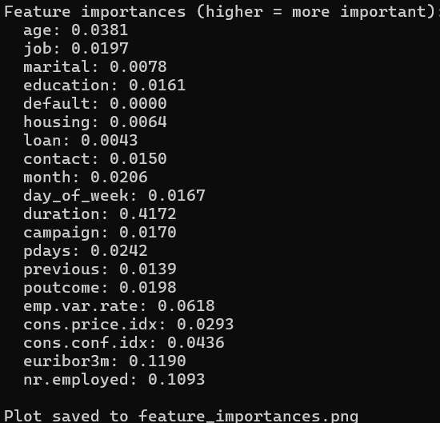
Figure 4-Feature importance

The chart shows importance scores sorted ascending (the most important features appear at the top). The score for each feature is its MDI and scores add up to 1 across all features.

The feature importance results show that duration (0.4172). This indicates that the length of the call is the strongest predictor of the target outcome, likely because longer interactions reflect greater customer engagement and a higher likelihood of success. However, this also introduces a limitation: since call duration is only known after the call has taken place, it may lead to data leakage and reduces the model’s usefulness for real-time prediction. The model still performs well because the remaining features are meaningful but this is an important caveat.
After duration, the most influential features are macroeconomic indicators,euribor3m (0.1190) and nr.employed (0.1093). This makes a lot of sense in context: this dataset covers 2008–2010, right through the financial crisis, and interest rate conditions at any given point in time would strongly affect whether customers were willing to lock money into a term deposit. Additional economic variables such as emp.var.rate (0.0619) and cons.price.idx (0.0292) further reinforce the significance of external financial factors in the model.
Moderately important features include pdays (0.0242), month (0.0206), poutcome (0.0198), job (0.0197), campaign (0.0170), day_of_week (0.0167), education (0.0161), and contact (0.0150). These variables contribute to the prediction but have a relatively smaller individual impact. They suggest that customer history, timing of contact and demographic information have some influence but are not dominant factors.
In contrast, features such as housing (0.0064), loan (0.0043), marital (0.0078), and especially default (0.0000) have minimal to no impact on the model’s predictions. This indicates that these attributes do not provide useful information for distinguishing between outcomes in this dataset.
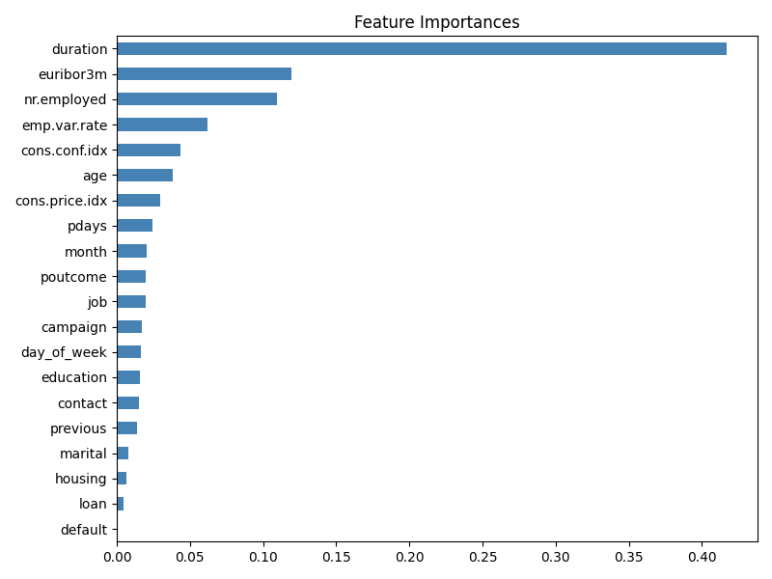
Figure 5-Feature importance

Comparing other techniques
Bagging
Bagging, the predecessor to Random Forrest, would likely do very well here since the technique is related, however it does have some drawbacks. It doesn’t have a direct equivalent to our usage of a balanced class_weight, which would make it harder to make it more aggressive in picking more potential customers. In general, Random forest also has better performance which can save on processing.

Decision tree
A single decision tree is the base learner that Random forest builds upon. Comparing against it directly isolates the benefit of the ensemble approach. In comparison to RF(Random forrest), a single decision tree is completely transparent,it produces human readable rules the bank can apply manually. However there is also high variance,small changes to training data can produce different trees. When the result must be a simple, auditable decision rule that compliance officers can review without software, for example, a printed flowchart for a call centre team.

Logistic regression
Logistic regression models the log-odds of the positive class as a linear combination of input features. It is the most common baseline classifier in banking due to its regulatory transparency. The limitation here is that it assumes a linear relationship between the features and the outcome. The interactions in this dataset, particularly between macroeconomic indicators and client demographics, are likely non-linear, which means logistic regression would struggle to capture them without a lot of manual feature engineering. Expected AUC on this dataset is around 0.78–0.82, well below the 0.947 achieved with Random forest. That said, for a bank that primarily needs a model it can easily audit and defend to regulators, Logistic regression is still a reasonable choice despite the performance trade-off.

Gradient boosting
Gradient boosting is probably the technique that would beat Random forest most convincingly on this specific problem. Instead of building trees in parallel and averaging them, boosting builds trees sequentially,each new tree focuses on correcting the mistakes made by the previous ones. This usually squeezes out higher performance on structured tabular data, with published benchmarks on this exact dataset showing AUC values of 0.95–0.96, slightly above the 0.947 achieved here.
The downside is that gradient boosting comes with significantly more hyperparameters to tune (learning rate, subsampling rate, column sampling, regularisation terms), which means a more complex and time consuming grid search. For this dataset size of 4,119 records the improvement over Random forest is relatively modest and not worth the extra tuning effort. At larger scales, a real bank with millions of customers ,that extra 1–2% AUC could translate to meaningful additional revenue, which is when gradient boosting becomes the better default choice.

MLP nueral networks
A neural network with hidden layers (MLPClassifier in scikit-learn) can theoretically learn any function given enough data and the right architecture. On very large datasets this can be powerful, but on a structured tabular dataset of 4,119 records like this one, tree based ensembles almost always win. Neural networks need a lot more data before the complex non-linear representations they learn start to outperform the simpler splitting rules of random forest.
There's also the interpretability problem: a neural network gives no native feature importance, no readable decision rules and the internal weights mean nothing to a non-technical audience. For a bank that needs to explain its marketing targeting decisions, this makes an MLP a harder sell than Random forest, even if the raw performance were comparable. It would become a more interesting option if the model were extended to incorporate unstructured data like call transcript text alongside the structured features.

